300 points for 3 problems, 100 points for each problem

- Virgo Cluster

The Virgo cluster of galaxies is the nearest large cluster which extends over nearly 10 degrees across the sky and contains a number of bright galaxies. It is very interesting to find the distance to Virgo and to deduce certain cosmological information from it. The table below provides the distance estimates using various distance indicators (listed in the left column). The right column lists the mean distance d_{i} ± the standard deviation s_{i}.

i | Distance Indicator | Virgo Distance (Mpc)
1 | Cepheids | 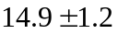
2 | Novae | 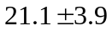
3 | Planetary Nebulae | 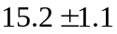
4 | Globular Cluster | 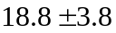
5 | Surface Brightness Fluctuation | 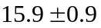
6 | Tully-Fisher relation | 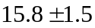
7 | Faber-Jackson relation | 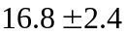
8 | Type Ia Supernovae | 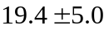

- By applying a weighted mean, compute the average distance (which can be taken as an estimate to the distance to Virgo)
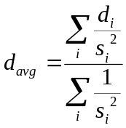
where the sum runs over the eight distance indicator used.
- What is the uncertainty (rms) (in unit of Mpc) in that estimate?
- Spectra of the galaxies in Virgo indicate an average recession velocity of 1136 km/sec for the cluster. Can you estimate the Hubble constant H₀ and its uncertainty (rms)?
- What is the Hubble Time (age of the universe) using the value of Hubble constant you found and the uncertainty (rms)?

II. Determination of stellar masses in a visual binary system

The star α-Centauri (Rigel Kentaurus) is a triple star which consists of two main-sequence stars α-Centauri A and α-Centauri B representing visual binary system, and the third star, called Proxima Centauri, which is smaller and fainter than the other two stars. The angular distance between α-Centauri A and α-Centauri B is 17.59”. The binary system has an orbital period of 79.24 years. The visual magnitudes of α-Centauri A and α-Centauri B are -0.01 and 1.34 respectively. Their color indices are 0.65 and 0.85 respectively. Use the data below to answer the following questions.

Data for main-sequence stars

(B –V)₀ | T_{eff} | BC
-0.25 | 24500 | 2.30
-0.23 | 21000 | 2.15
-0.20 | 17700 | 1.80
-0.15 | 14000 | 1.20
-0.10 | 11800 | 0.61
-0.05 | 10500 | 0.33
0.00 | 9480 | 0.15
0.10 | 8530 | 0.04
0.20 | 7910 | 0
0.30 | 7450 | 0
0.40 | 6800 | 0
0.50 | 6310 | 0.03
0.60 | 5910 | 0.07
0.70 | 5540 | 0.12
0.80 | 5330 | 0.19
0.90 | 5090 | 0.28
1.00 | 4840 | 0.40
1.20 | 4350 | 0.75
BC=Bolometric Correction, (B-V)₀=Intrinsic Color

Questions:
- Plot the curve BC versus (B-V)₀.
- Determine the apparent bolometric magnitudes of α-Centauri A and α-Centauri B using the corresponding curve.
- Calculate the mass of each star.

Notes:
- Bolometric correction (BC) is a correction that must be made to the apparent magnitude of an object in order to convert an object's visible magnitude to its bolometric magnitude:
BC = m_{v} - m_{bol} or BC = M_{v} - M_{bol}
- Luminosity mass relation : 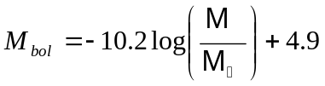

III. The Age of Meteorite

The basic equation of radioactive decay can be expressed as:
N(t) = N₀ exp (-λt)

where N(t) and N₀ are the number of remaining atoms of the radioactive isotope (or parent isotope) at time t and its initial number at t = 0, respectively, while λ is the decay constant. The decay of the parent produces daughter nuclides D(t), or radiogenics, which is defined as
D(t) = N₀ – N(t) .

Based on those ideas, a group of astronomers investigates a number of meteorite samples to determine their ages. They have two kinds of samples: allende chondrite (A) and basaltic achondrite (B). From the samples, they measure the abundance of ⁸⁷Rb and ⁸⁷Sr, where it is assumed that ⁸⁷Sr is entirely produced by the decay of ⁸⁷Rb. The value of λ is 1.42 × 10⁻¹¹ per year for this isotopic decay. In addition, non-radiogenic element ⁸⁶Sr is also measured. Results of measurement are given in the table below, expressed in ppm (part per million).

Sample No | Meteorite type | ⁸⁶Sr (ppm) | ⁸⁷Rb (ppm) | ⁸⁷Sr (ppm)
1 | A | 29.6 | 0.3 | 20.7
2 | B | 58.7 | 68.5 | 44.7
3 | B | 74.2 | 14.4 | 52.9
4 | A | 40.2 | 7.0 | 28.6
5 | A | 19.7 | 0.4 | 13.8
6 | B | 37.9 | 31.6 | 28.4
7 | A | 33.4 | 4.0 | 23.6
8 | B | 29.8 | 105.0 | 26.4
9 | A | 9.8 | 0.8 | 6.9
10 | B | 18.5 | 44.0 | 15.4

Questions:
- Express the time t in term of 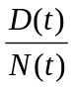
- Determine the half-life t_{1/2}, i.e., the time needed to obtain a half number of parents after decay.

- Knowledge on the ratio between two isotopes is more valuable than just the absolute abundance of each isotope. It is quite likely that there was some initial strontium present. By taking 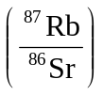 as independent variable and 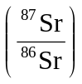 as dependent variable, estimate the simple linear regression model to represent the data.

- Plot versus and also the regression line (isochrone) for each type of the meteorites. (Please use minimum 7 decimal digits for intermediate calculations)

- Subsequently, help this astronomer to determine the age of each type of the meteorites and its error. Which type is older?

- Determine the initial value of 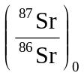 for each type of the meteorites and its error.

Glossary:
A simple linear regression line y=a+bx can be fitted to a set of data (X_{i},Y_{i}), i=1,…,n, in which
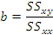
where
SS_{xx} : sum of square for X = 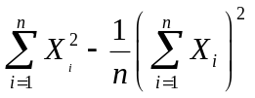
SS_{yy} : sum of square for Y = 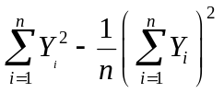
SS_{xy} : sum of square for both X and Y =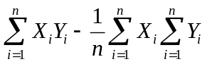
Standard deviation of each parameter, a and b can be calculated by

